A An Truong Primary School.  Full name: ………………………….........  Class: ………………………… | THE FRIST TERM TEST FOR GRADE 4  School year: 2025-2026  Time allowed: 60 minutes
Skills | Listening | Reading | Writing | Speaking | Total
Marks
Comments: |  |  |  | Supervisor signature
LISTENING (3 marks)
TASK 1. Listen and tick (1mark)
a
b
b
a
a
b
a
b
1. |  | 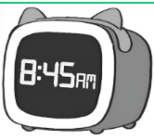
2. |  | 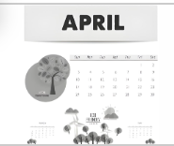
3. | 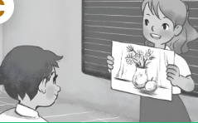 | 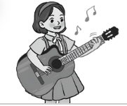
4. |  | 
TASK 2. Listen and number. (1 mark)
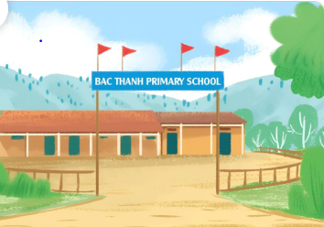 | 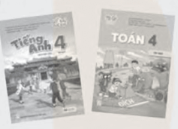  b. |   c. |   d.
TASK 3. Listen and circle. (1 mark)
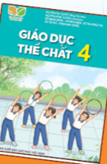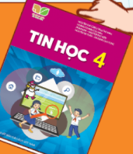  2.  1. |   a b
  a b
  3.  a b |   4.  a b
SPEAKING (2 marks)
1. Get to know each other and answer the questions. (1 mark)
Suggested questions:
- What’s your name?
- Where are you from?
- When’s your birthday?
- What’s your favourite subject?
2. Look and answer. (1 mark)
1. What do you do on Tuesdays? | 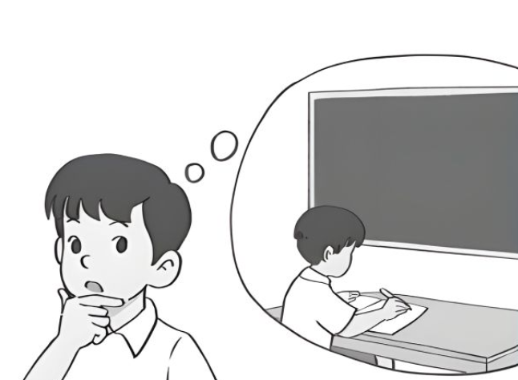 | 4. Where’s your school? | 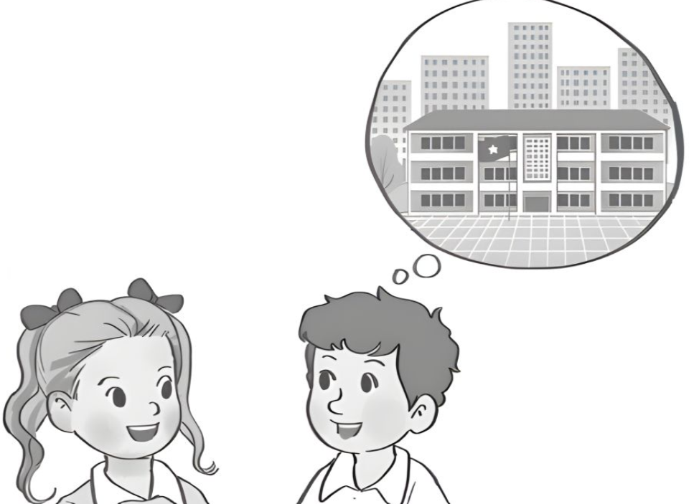
2. Can you roller skate? | 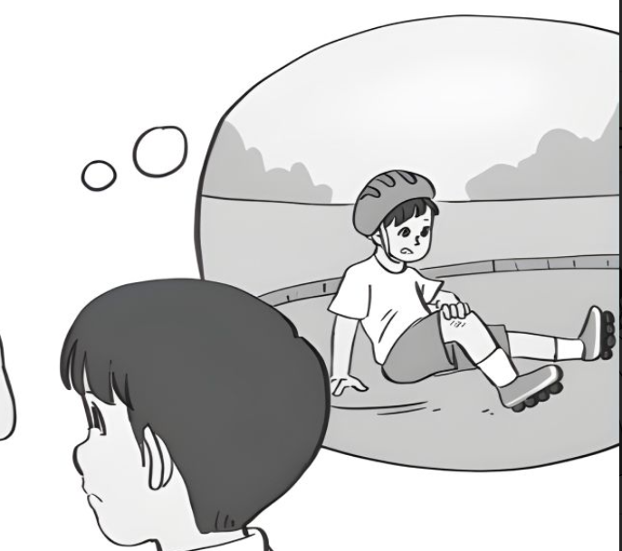 | 5. What subjects do you have today? | 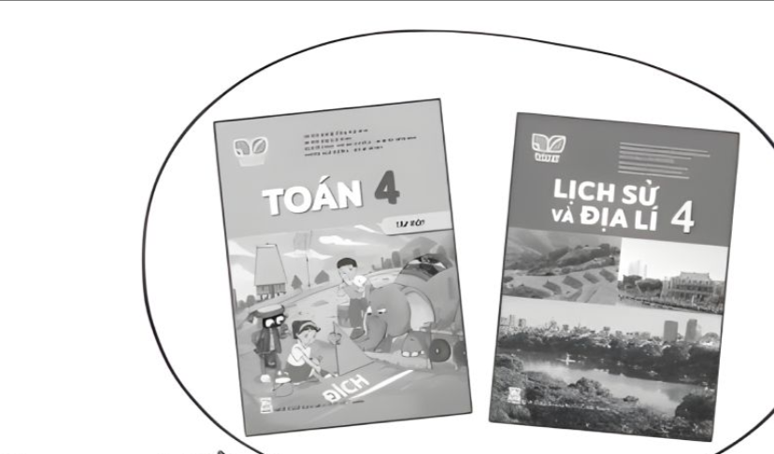
3. What time do you go to bed? | 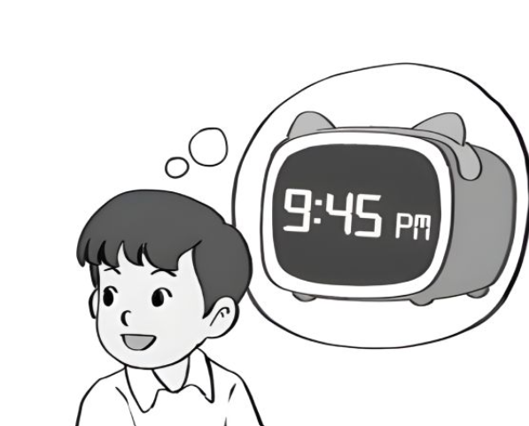 | 6. When’s your Sports day? | 

A An Truong Primary School.  Full name: ………………………….........  Class: ………………………… | THE FRIST TERM TEST FOR GRADE 4  School year: 2025-2026  Time allowed: 30 minutes

READING ( 2,5 mark)
TASK 1. Look and tick ☑ or cross 🗵 (1.25 marks)
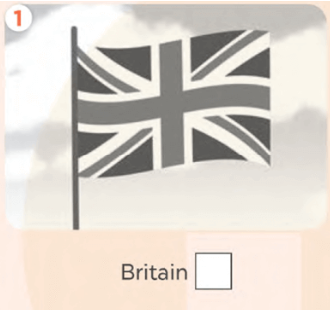 | 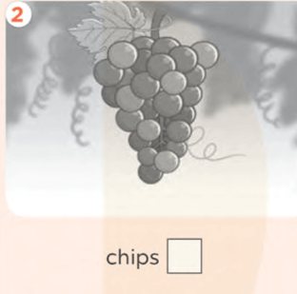 |  | 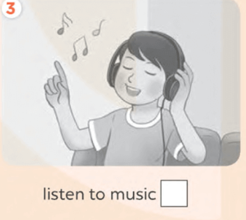
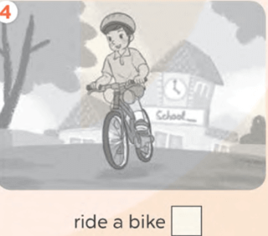 |  | 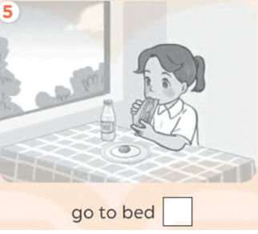

TASK 2. Read and circle. (1.25 marks)
We have a lot of fun at school. In our English lessons, we (1) __________ to English songs. We sing and chant. We (2) _______________ board games to learn English. (3)_____________ do projects together at the end of each unit. (4)_______________, it was sunny. We (5) ____________ in the school garden. There were many flowers and birds. We were happy.
1. | a. listen | b. write | c. speak
2. | a. read | b. play | c. sing
3. | a. They | b. You | c. We
4. | a. Yesterday | b. Now | c. Weekend
5. | a. are | b. was | c. were

WRITING (2,5 marks)
I. Look and write. (1,25 marks)
Hello, my name is Nam. I am ten years old. I’m from  (1) _____________. I study in a school in HCM city. There is a big 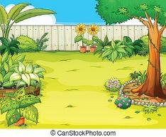(2) _____________ at my school. My favourite subject is 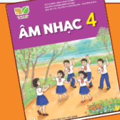 (3) ______________. I also like computers a lot! There is one 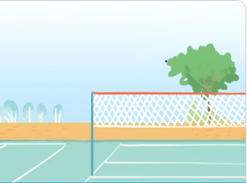 (4)______________ where we play football everyday. After school, I often 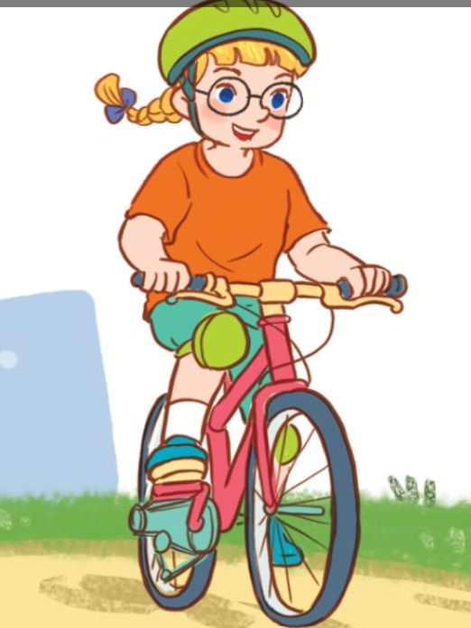 (5)_______________________ in the park with my friends.
TASK 2. Reorder the words to make correct sentences ( 1.25 mark)
1. do you/ What time/ have breakfast?

2. some water/ want/ I.

3. play/ He/ the piano/ can.

4. on Saturdays/ listen to music/ I.

5. she/ Where is/ from?

